Health Research Council of New Zealand

Pulmonary Model-based Decision Support to Optimise ARDS/ ALI Care (PulMoDS)

Data Monitoring Committee Open Statistical Report:

No. XX, Date: XX/ MM/ YYYY
Sample: All values, dates, figures and tables are generated for illustration purpose only

Contents
1. | Introduction | 3
2. | Subject Accrual | 3
3. | Data Availability and Completeness | 6
4. | Patients Retracts from the Trial | 7
5. | Serious Adverse Events Reporting | 8

List of Figures
1. | Figure 1: Patients randomised over time. The dotted straight line depicts target accrual. The solid black line depicts randomised subjects. The colour line depicts the number of patients screened. | 3
2. | Figure 2: Number of patients randomised based on APACHE III Diagnostic Code. Data from 01/ 07/ 2000 to 31/ 12/ 2000. | 4
3. | Figure 3: Number of patients randomised based on APACHE III Diagnostic Code. Data to date from 01/ 01/ 2000 to 31/ 12/ 2000. | 5
4. | Figure 4: Patient retracts from the trial before completion. | 6

List of Tables
1. | Table 1: Number of patients randomised for each APACHE III Diagnostic Code. Data from 01/ 07/ 2000 to 31/ 12/ 2000. | 4
2. | Table 2: Number of patients randomised for each APACHE III Diagnostic Code. Data to date from 01/ 01/ 2000 to 31/ 12/ 2000. | 5
z3. | Table 3: Data availability for patients randomised from 01/ 07/ 2000 to 31/ 12/ 2000. | 6
4. | Table 4: Data availability for patients randomised to date. From 01/ 01/ 2000 to 31/ 12/ 2000. | 6
5. | Table 5: Summary of Serious adverse events | 8
1.0 Introduction
The following is the Pulmonary Model-based Decision Support to Optimise ARDS/ ALI Care (PulMoDS) Open Statistic Report for Data Monitoring Committee, on the data gathered till 31/ 12/ 2000. The report was generated on 31/ 01/ 2001.

2.0 Subject Accrual
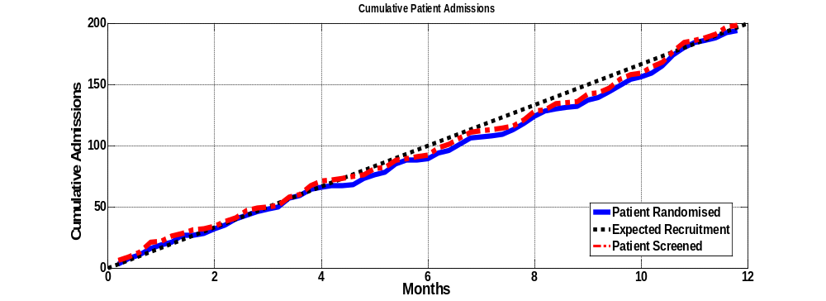
Figure 1: Patients randomised over time. The dotted straight line depicts target accrual. The solid black line depicts randomised subjects. The colour line depicts the number of patients screened.

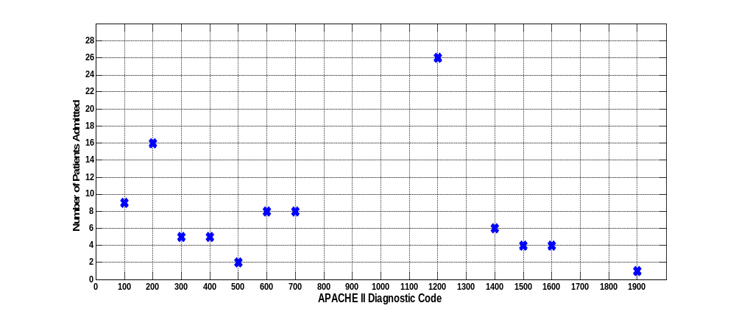Figure 2: Number of patients randomised based on APACHE III Diagnostic Code. Data from 01/ 07/ 2000 to 31/ 12/ 2000.

Table 1: Number of patients randomised for each APACHE III Diagnostic Code. Data from 01/ 07/ 2000 to 31/ 12/ 2000.
 | APACHE III Code | Description | No. Patient
 | APACHE III Code |  | Control | Intervention | Total
 | 0 | No diagnosis entered
Non - Operative | 100 | Cardiovascular | 8 | 1 | 9
Non - Operative | 200 | Respiratory | 8 | 8 | 16
Non - Operative | 300 | Gastrointestinal | 3 | 2 | 5
Non - Operative | 400 | Neurological | 3 | 2 | 5
Non - Operative | 500 | Sepsis | 0 | 2 | 2
Non - Operative | 600 | Trauma | 1 | 7 | 8
Non - Operative | 700 | Metabolic | 3 | 5 | 8
Non - Operative | 800 | Haematology
Non - Operative | 900 | Renal disorder
Non - Operative | 1000 | Other medical disorders
Non - Operative | 1100 | Musculoskeletal/ Skin disease
Post- Operative | 1200 | Cardiovascular | 14 | 12 | 26
Post- Operative | 1300 | Respiratory
Post- Operative | 1400 | Gastrointestinal | 2 | 4 | 6
Post- Operative | 1500 | Neurological | 1 | 3 | 4
Post- Operative | 1600 | Trauma | 1 | 3 | 4
Post- Operative | 1700 | Renal/ Genitourinary
Post- Operative | 1800 | Gynaecological
Post- Operative | 1900 | Musculoskeletal | 1 | 0 | 1
Post- Operative | 2100 | Haematological
Post- Operative | 2200 | Metabolic
Total |  |  | 45 | 49 | 94

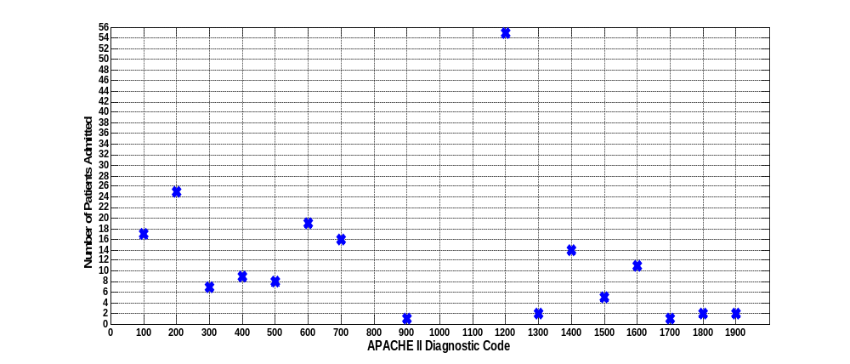
Figure 3: Number of patients randomised based on APACHE III Diagnostic Code. Data to date from 01/ 01/ 2000 to 31/ 12/ 2000.

Table 2: Number of patients randomised for each APACHE III Diagnostic Code. Data to date from 01/ 01/ 2000 to 31/ 12/ 2000.
 | APACHE III Code | Description | No. Patient
 | APACHE III Code |  | Control | Intervention | Total
 | 0 | No diagnosis entered
Non - Operative | 100 | Cardiovascular | 11 | 6 | 17
Non - Operative | 200 | Respiratory | 12 | 13 | 25
Non - Operative | 300 | Gastrointestinal | 4 | 3 | 7
Non - Operative | 400 | Neurological | 4 | 5 | 9
Non - Operative | 500 | Sepsis | 2 | 6 | 8
Non - Operative | 600 | Trauma | 12 | 7 | 19
Non - Operative | 700 | Metabolic | 5 | 11 | 16
Non - Operative | 800 | Haematology
Non - Operative | 900 | Renal disorder | 1 | 0 | 1
Non - Operative | 1000 | Other medical disorders
Non - Operative | 1100 | Musculoskeletal/ Skin disease
Post- Operative | 1200 | Cardiovascular | 22 | 33 | 55
Post- Operative | 1300 | Respiratory | 2 | 0 | 2
Post- Operative | 1400 | Gastrointestinal | 10 | 4 | 14
Post- Operative | 1500 | Neurological | 2 | 3 | 5
Post- Operative | 1600 | Trauma | 8 | 3 | 11
Post- Operative | 1700 | Renal/ Genitourinary | 1 | 0 | 1
Post- Operative | 1800 | Gynaecological | 2 | 0 | 2
Post- Operative | 1900 | Musculoskeletal | 2 | 0 | 2
Post- Operative | 2100 | Haematological
Post- Operative | 2200 | Metabolic
Total |  |  | 100 | 95 | 194

3.0 Data Availability and Completeness
Table 3: Data availability for patients randomised from 01/ 07/ 2000 to 31/ 12/ 2000.
Month | Number of patients |  | Number of patients with complete data
 |  |  | Arterial Blood Gas | SPO2 | LoMV | X Rays
1 | 9 |  | 7^{(a)} | 9 | 9 | 6^{(b)}
2 | 2 |  | 11 | 11 | 11 | 5
3 | 4 |  | 8 | 8 | 8 | 7
Total

* Notes:
(a) 2 patients do not have complete ABG data:
1 patient do not have all the data.
1 patient had 4/5 of the data.
(b) 2 patients do not have complete ABG data:
3 patients had 4/5 of the data.

Table 4: Data availability for patients randomised to date
Month | Number of patients |  | Number of patients with complete data
 |  |  | Arterial Blood Gas | SPO2 | LoMV | X Rays
Total

4.0 Patients Retracts from the Trial
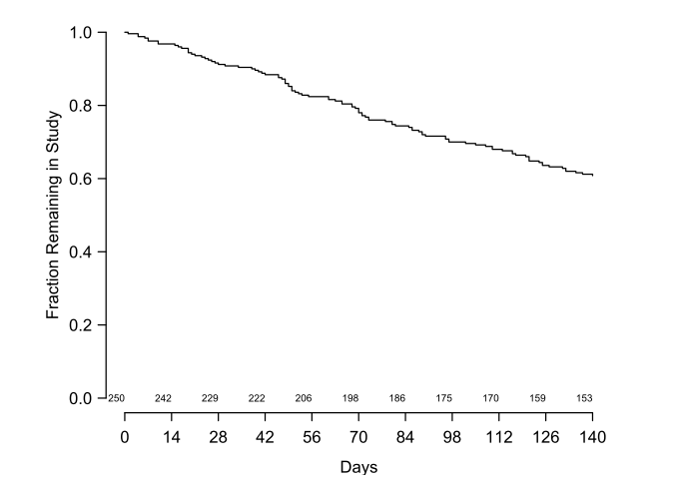
Figure 4: Patient retracts from the trial before completion.

5.0 Serious Adverse Events (SAE) Reporting
Table 5: Summary of serious adverse events
No. of Patients | SAE types
 | Death
 | Life threatening
 | Prolongation of Hospitalisation
 | Results in disability and incapability
 | Others
*Include individual patient report (De identified)
A sample is shown below

Serious Adverse Events (SAE) Reporting

Patient Trial Number

SAE Diagnosis:

SAE Types
 | Death |  | Result in disability and incapability
 | Life Threatening |  | Others (Please Specify)
 | Prolongation of Hospitalisation |  | Others (Please Specify)

SAE Description and Treatment:

Principal/ Investigator Suspected Relationship of SAE to Study Treatment:
Not Related
Unlikely
Possible
Probably
Definitely

SAE Onset Date: ______/______/__________ (DD/ MM/ YYYY)

SAE Resolution Date: ______/______/__________ (DD/ MM/ YYYY)

Death Date: ______/______/__________ (DD/ MM/ YYYY)

Outcome:
Unknown/
Lost to Follow Up
 | Unresolved
 | Resolved
 | Resolved with Sequels | Please Specify
 | Death | Cause of Death
 | Death | Autopsy |  | Report Attached
 | Death | Autopsy |  | Not Done

Action Taken with Study Protocol:
None
Recruitment Manoeuvre or PUMP manoeuvre changed/ Temporary discontinued
Termination of Recruitment Manoeuvre or PUMP

Additional Notes:

Investigator’s Signature:

Investigator’s Name:

Date: ______/______/__________

